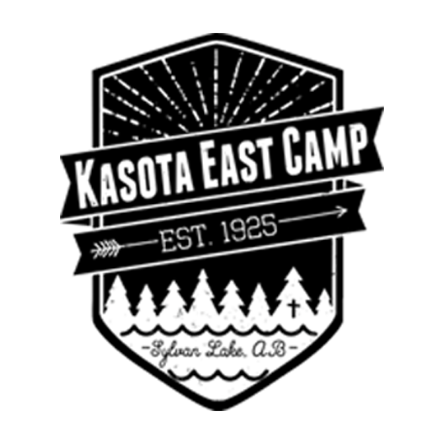
ONLINE SUMMER PROGRAMMING SCHEDULE
Each Monday we will announce our theme for the week. Families and campers are encouraged to participate in the theme during the week. Families and campers can share photos and videos of them participating and tag the camp Facebook, and Instagram. As well, parents can choose if they would like their video to be added to a mashup of these videos and added to the camp’s social media (waivers will need to be signed for this). Some weeks will even include special prizes!
E-mail summerdirector@kasotaeastcamp.org Facebook: Kasota East Camp Instagram: kasotaeastcamp Kasota East Camp

CODE OF CONDUCT FOR PARTICIPATION IN KEC SOCIAL MEDIA & ONLINE PROGRAMMING | IF YOU PLAN TO SHARE STORIES, PHOTOS, VIDEO, AND/OR AUDIO WITH US...
Share content and participate in ways that make others feel welcome and included.  - Maintain respectful dialogue.  - Notify us if you notice content that might make others feel  unwelcome, excluded, or unsafe.  Share content and participate in ways that reflect our spirit of inclusivity:  We welcome and affirm the value of having people of all ages, religions, genders, sexual orientations, races, bodies and abilities, and socio-economic realities, participate in our programming.  Share content and participate in ways that are appropriate for people of all ages. Consider our social media as being rated “G” for a general audience.  Share content and participate in ways that respect the rights and privacy of others.  - Please do not share content without getting the permission of everyone involved in it. It is best practice to “tag” these people so they know.  - Please do not post content that involves minors unless they consent AND you are their parent or guardian.  - Please do not post or tag KEC in products or events without getting our permission in advance. | FILL OUT CONSENT FORM HERE : https://bit.ly/2BY88OM  If you are submitting stories, photos and/or video and sound recordings for Kasota East Camp to use for promotional purposes including social media, print media, physical displays, and videos, please note the following:  1- Each person in the media you share must provide consent for KEC to use the media as outlined above.  2-A legal adult guardian must provide consent for minors under the age of 18 years old at the time the video is being submitted.  3- You can specify whether you are providing consent for a single submission, or if you would like to provide consent for all media you submit within the summer programming period of July 13-August 30, 2020.

July
Monday | Tuesday | Wednesday | Thursday | Friday | Saturday | Sunday
13  Pie-in-the-face Challenge  Alumni Camp Photo | 14  Vote!  CYOA | 15  Vote!  CYOA | 16  Vote!  Vespers | 17  Vote! | 18  Someone is getting pied... | 19
20  Scavenger Hunt | 21  Clue #2 Drops!  CYOA | 22  Clue #3 Drops!  CYOA | 23  Clue #4 Drops!  Campfire | 24 | 25  Scavenger Hunt Mash-Up Video | 26  Alumni Photo Winners Announced
27  Polar Dip Challenge | 28  CYOA | 29  CYOA | 30  Community Convo | 31 | 1  Polar Dip Mash-Up Video | 2

August
Monday | Tuesday | Wednesday | Thursday | Friday | Saturday | Sunday
3  Art Week | 4  CYOA | 5  CYOA | 6  Vespers |  | 8  Art Goes Live | 9
10  Talent Show Week | 11  CYOA | 12  CYOA | 13  Community Convo |  | 15  Talent Show Mash-Up Video | 16
17  T-Shirt Logo Contest Starts | 18  CYOA | 19  CYOA | 20  Campfire |  | 22 | 23
24  Cookout Week | 25  CYOA | 26  CYOA  T-Shirt Logos Go Live | 27  Vespers | 28 | 29  Cookout/End of Summer Mash-Up Video | 30

Calendar Event Breakdown
CYOA: Choose Your Own Adventure are mini-sessions you can do from home! We will upload videos on Tuesday and Wednesday of different mini-sessions that you would normally see at camp, but that we have adapted for home! This may also give you a chance to see some of your favourite staff members!
PIE challenge: This week we will honor one of the best and funniest camp traditions, the pie in the face! Each day two counselors will be paired up and you will get to vote on who you want to see pied more! At the end of the week we just may get to see that counselor get pied for real!
Alumni Photo Week: KEC alumni are encouraged throughout the week of photos of them at camp. Along with the photo they can add a caption of what the photo is and what it means to them. All participants are encouraged to tag camp and fellow campers or staff in their posts and challenge them to do the same!
Scavenger Hunt week: Throughout the week, each day new clues will be released. The scavenger hunt clue will be things that everyone can find in their own home or neighbourhood and will be camp themed. We enocurgae you to document your journey and tag KEC!
Polar Dip Week: This week, we will have a challenge that simulates our chilly polar dip! Participants can try to do this activity every day to get the full experience. Make sure to show us your reactions to the cold!
Talent Show Week: Sadly, no camp means no talent shows! However we still want to see your talents! This week, campers can film the talents they wanted to show off and tag camp. At the end of the week we will have a big virtual talent show mashup for those who want to participate!
Art activity: This week's activity will extend beyond one week but we will still release a video on Friday for those who want to be in it. We will explain and release an art project that can be done at home and will show how camp stays together even when we are apart!
T-Shirt Logo Week: This week, we will be having a theme related t-shirt design challenge. The winner of which just might get to see your design on camp shirts next year!
Cookout week: This week we want our beautiful camp family to try to make some time to have a cookout. Whether it be over a fire or just a nice picnic, we think making hot dogs and marshmallows is an extra fun part of camp! Snap some pics and videos and cherish this time as well as include the camp family by tagging KEC and sharing your video to the mashup.
Vespers and Community Convo: Vespers and community convo will be a virtual version of what we do at camp. We will include songs, prayers, activities and everything that makes these things special. Community Conversation will be hosted by a special friend to camp!
Campfire: Though campfire can’t quite be the same, we still want to bring a bit of what makes campfire so special. Watchout for these videos that will come out every few weeks, and keep a special eye out for former staff!

